Name _______________

How to Buy “Smart” When Shopping

Unit Pricing

Have you ever been in a supermarket and had trouble deciding which of two items was the “best buy”? Here’s what you can do.

In a supermarket each item is marked with a price and a size. The common STANDARD UNITS of size are as follows:
- Weight – kg, g, pound (lb), ounces (oz)
- Volume – liter, gallon, quart
- Length – meter, centimeter (cm), foot, mile

You can calculate the unit price by dividing the price by the size measured in the standard unit.

You can decide which item is the “best buy” by comparing the unit prices.

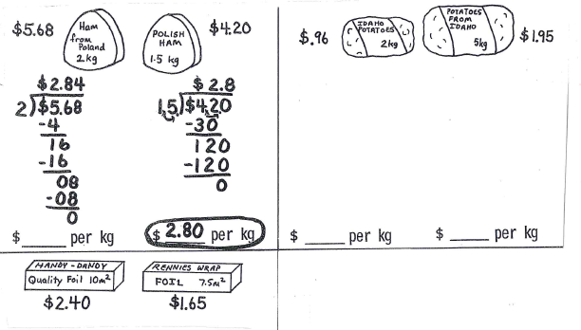

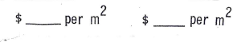
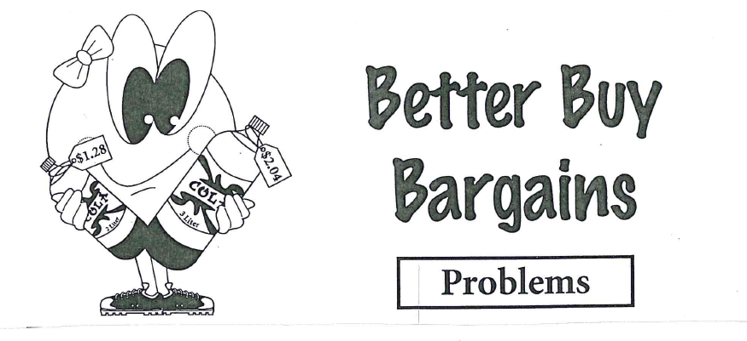

1) Thomas is shopping for chicken.  One brand has a 3 lb. package for $5.25. Another brand has a 2 lb. package for $3.60.  Which package is the better buy?  Explain your answer. | 2) Judy found a 6 oz. can of orange juice for $0.72 and a 9 oz. can for $1.17.  Which is the better buy?  Explain your answer.
3) Tonya wants to buy toothpaste.  She can choose between a 6 oz. tube for $1.26 or an 8 oz. tube for $1.60.  Which is the better buy and why? | 4) Terry needs 8 oz. of tomato paste for her spaghetti sauce. Should she buy several 4 oz. cans costing $.60 each or the 10 oz. can for $1.00?  Explain your answer.

WORD PROBLEMS

Read each problem carefully, decide whether to multiply or divide and then solve.

5) Helen bought presents for each of her 4 children and spent $37.24 altogether.  Each present cost the same amount.  How much did each present cost? | 6) Sue paid $15.54 for gas. The gas cost $.37 per liter.  How many liters did she buy?
7) Joe worked for 6 hours and earned $40.20.  How much did he earn per hour? | 8) Jim lives 17.4 km from his job.  He drives to and from work every day.  He works 5 days a week.  How far does he drive to and from work every week?

